Assignment – 1

* Install Power BI Desktop and share the final screenshot of the report view page which appears when power desktop starts.

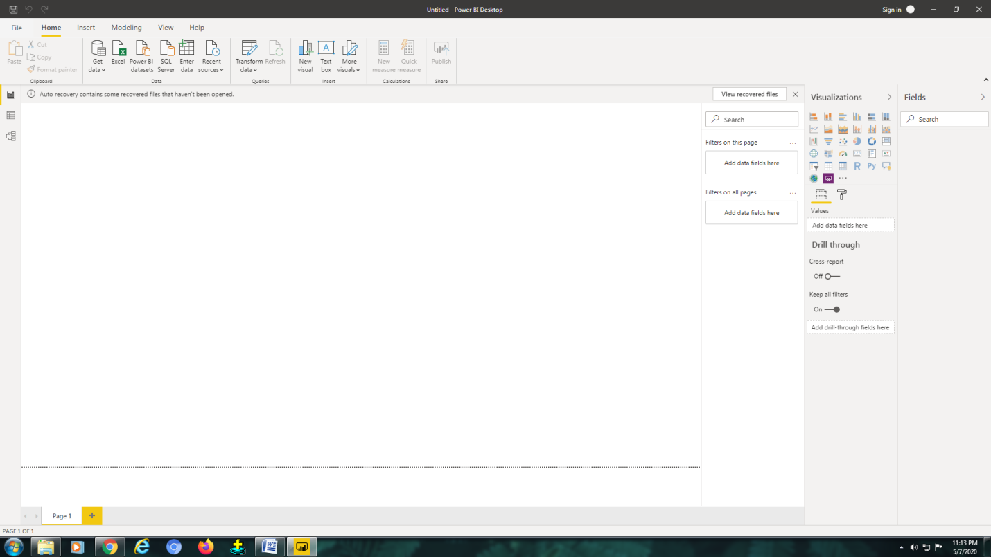

• Prepare a document and with the following screenshot

Report View :

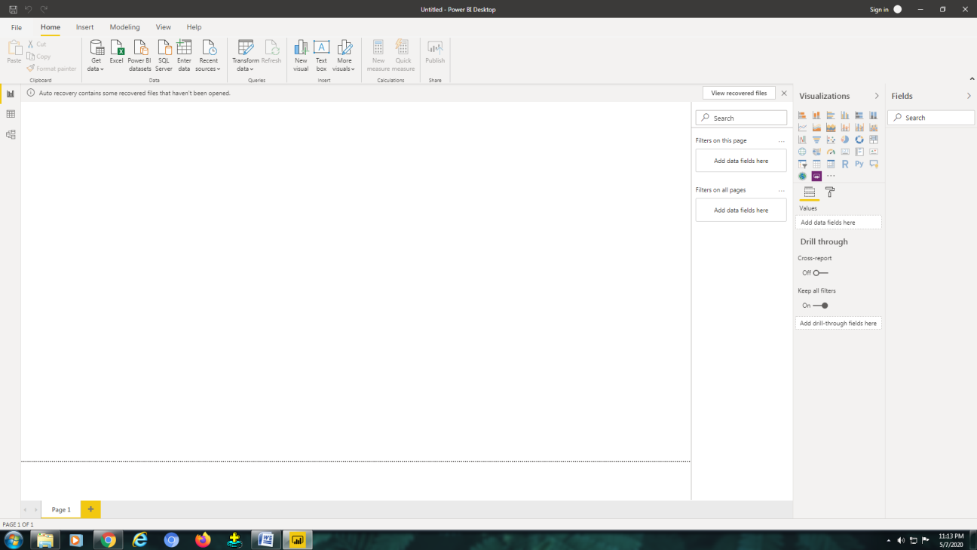

− Data View :

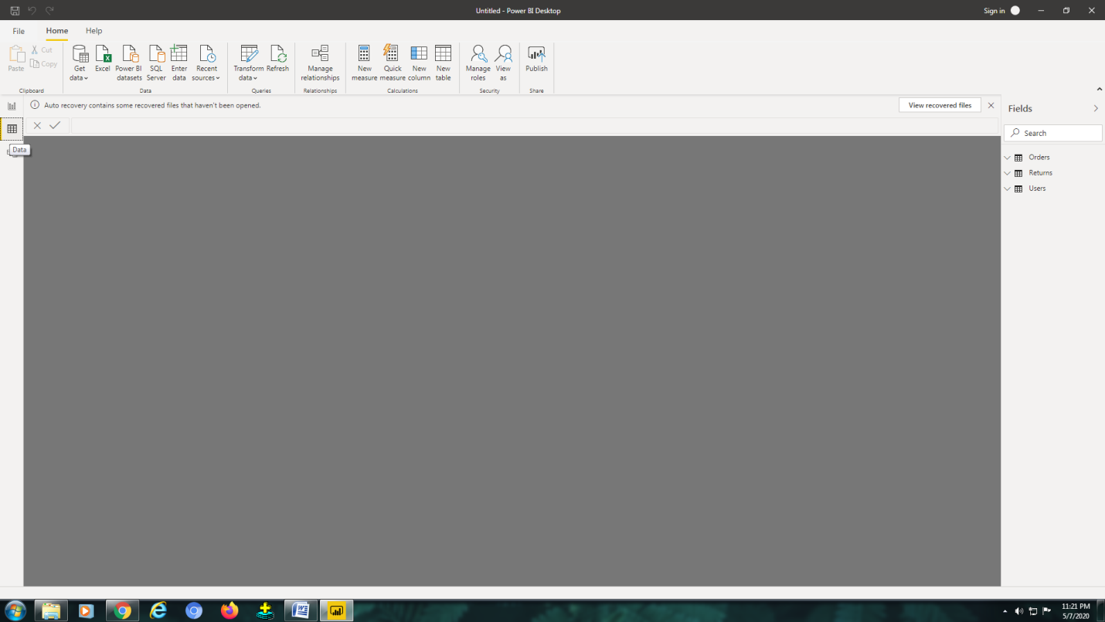

Power Query Editor :

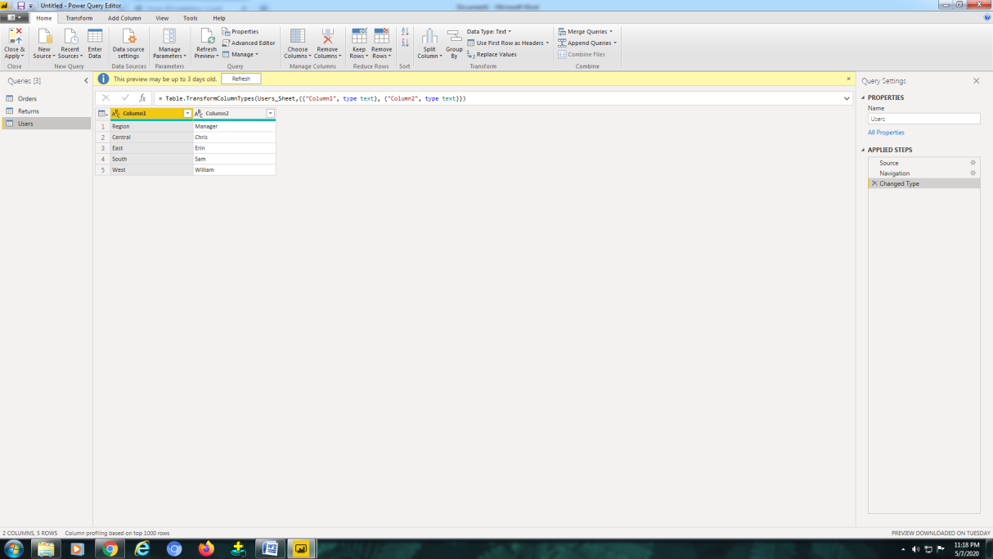

Advance Editor :

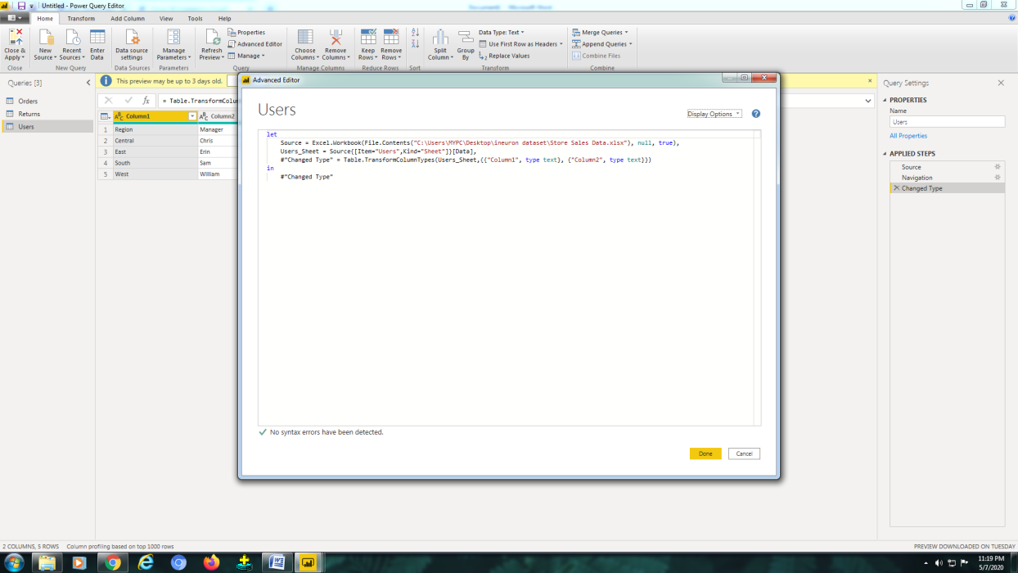

− Model View :

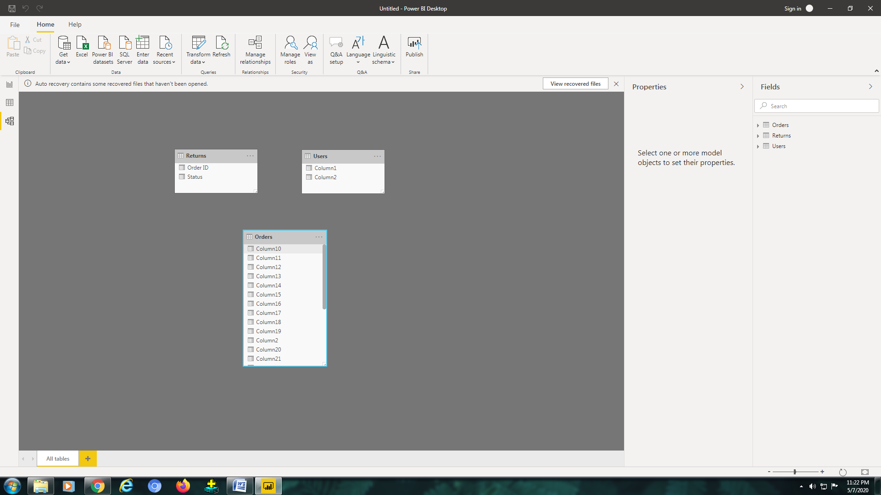

* Prepare a document with details of the following along with their price

Power BI Pro and Premieum :

